CRIME AWARENESS SYSTEM USING MACHINE LEARNING
Minor Project
Submitted by
Sujeet Kumar (MRT24UGBCA075)
Dheeraj Kumar (MRT24UGBCA041)



Department of Computer Science & Engineering
Faculty of Engineering & Technology

SHOBHIT UNIVERSITY, MEERUT
MAY 2026

ACKNOWLEDGEMENTS

I would like to express my sincere gratitude to my project guide
(Miss Priyanka Saini )for her continuous guidance, encouragement, and
valuable suggestions throughout the project.
I also thank the Department of Computer Science, Shobhit University,
for providing the necessary resources and support.
Finally, I thank my friends and family for their motivation and help
during the project.

1.Sujeet Kumar
2.Dheeraj kumar

TABLE OF CONTENTS

Contents Page No.

- Acknowledgement…………………………………………………………………………………………..i
- Table of contents…………………………………………………………………………………………….ii
- List of Abbreviations……………………………………………………………………………………….iii
- List of Figures………………………………………………………………………………………………….iv
- List of Tables……………………………………………………………………………………………………v

1. INTRODUCTION 7
1.1 Importance of crime awareness…………………………………………7
1.2 Why machine learning is used…………………………………………..7
1.3 Objectives of the system………………………………………………...7
1.4 Scope of the project……………………………………………………..7
1.5 Overview of dataset and tools used……………………………………..7
2. SYSTEM ANALYSIS 8
2.1 Existing system………………………………………………………….8
2.2 Limitation of existing system……………………………………………8
2.3 Proposed system………………………………………………………....8
2.4 System requirement(Hardware+Software)……………………………....8
3. SOFTWARE DESIGNING 9
3.1 Dataflow diagram(Level 0,1)………………………………………….....9
3.2 Used case diagram……………………………………………………….10
3.3 System architecture………………………………………………………10
3.4 Module description………………………………………………………11
4. IMPLEMENTATION SUMMARY 13
4.1 app.py implementation of app.py………………………………………...13
4.2 ML model training summary…………………………………………….14
4.3 Screenshot (UI + Graphs)………………………………………………..14
5. TESTING 19
5.1 Unit testing……………………………………………………………….19
5.2 Integration testing………………………………………………………...19
5.3 System testing…………………………………………………………….20
5.4 Module accuracy testing …………………………………………………20
6. CONCLUSION…………………………………………………………………...20
6.1 Summary…………………………………………………………………20
6.2 Result…………………………………………………………………….21
6.3 Limitation………………………………………………………………..21
6.4 Future enhancement …………………………………………………….21

LIST OF ABBREVIATION

Abbreviation | Full form
AI | Artificial Intelligence
API | Application Programming Interface
BCA | Bachelors of Computer Applications
CSV | Comma Separated Values
DFD | Data Flow Diagram
EDA | Exploratory Data Analysis
GCP | Google Cloud Platform
IDE | Integrated Development Environment
IPYNB | Interactive Python Notebook
JSON | JavaScript Object Notation
ML | Machine Learning
MAE | Mean Absolute Error
MSE | Mean Squared Error
R2 | Coefficient of Determination
OS | Operating System
PCA | Principal Component Analysis
PDF | Portable Document Format
PNG | Portable Network Graphics
RAM | Random Access Memory
RF | Random Forest
SSD | Solid State Drive

LIST OF FIGURES

Figure No. | Figure Title
1 | Rape cases in selected states over years 18-19
2 | Cases in Lucknow over year 19
3 | Trend of Arson in selected cities 20
4 | Crime counter distribution 20
5 | Frequency of crime type 21
6 | Total crimes by states 22-23
7 | Crime trend over year 22-23
8 | Actual vs predicted crime values 23
9 | Model error distribution 23-24
10 | Feature importance 24

LIST OF TABLES

State | District | City | Year | Crime Type | Crime Count
Andhra Pradesh | Adilabad | Nan | 2001 | Murder | 100
Andhra Pradesh | Anantapur | Nan | 2001 | Murder | 101
Andhra Pradesh | Chittor | Nan | 2001 | Murder | 102
Andhra Pradesh | Krishna | Nan | 2001 | Murder | 103
Andhra Pradesh | Guntur | Nan | 2001 | Murder | 104
Andhra Pradesh | Kudapan | Nan | 2001 | Murder | 105
Andhra Pradesh | East | Nan | 2001 | Murder | 106
Andhra Pradesh | west | Nan | 2001 | Murder | 107
Andhra Pradesh | Medak | Nan | 2001 | Murder | 108
Andhra Pradesh | Smi | Nan | 2001 | Murder | 109
Andhra Pradesh | Gkp | Nan | 2001 | Murder | 110
Andhra Pradesh | Dgp | Nan | 2001 | Murder | 111
Andhra Pradesh | Smtp | Nan | 2001 | Murder | 112
Andhra Pradesh | Ara | Nan | 2001 | Murder | 113
Andhra Pradesh | Chhapra | Nan | 2001 | Murder | 114
Andhra Pradesh | Siwan | Nan | 2001 | Murder | 115
Andhra Pradesh | Betiya | Nan | 2001 | Murder | 116
Andhra Pradesh | Bhojpur | Nan | 2001 | Murder | 117
Andhra Pradesh | Munger | Nan | 2001 | Murder | 118
Andhra Pradesh | Sasaram | Nan | 2001 | Murder | 119
Andhra Pradesh | Simra | Nan | 2001 | Murder | 120
Andhra Pradesh | Araiya | Nan | 2001 | Murder | 121
Andhra Pradesh | Chakdaud | Nan | 2001 | Murder | 35
Andhra Pradesh | Supaul | Nan | 2001 | Murder | 63

1. INTRODUCTION
1.1 Importance Of Crime Awareness
Crime awareness plays a vital role in ensuring the safety and well-being of individuals and communities. When people are aware of crime patterns around them, they become more cautious, make informed decisions, and take preventive measures. Awareness also helps authorities plan better policing strategies and allocate resources to high-risk areas. By understanding the frequency and nature of crimes in particular locations, societies can work towards reducing crime rates and improving overall public safety. A crime-aware community is better prepared to avoid dangerous situations and support stronger crimeprevention initiatives

1.2 Why Machine Learning is Used

Machine Learning is used in crime prediction because it can analyze very large datasets that humans cannot evaluate manually. ML algorithms identify hidden patterns, correlations, and trends in crime data such as location, crime type, and year. These patterns help generate predictions about future crime occurrences with good accuracy. Machine Learning also improves decision-making by providing data-driven insights rather than assumptions. Since crime data is large, complex, and dynamic, ML is an ideal tool to handle it efficiently and learn from it continuously. This makes crime prediction faster, smarter, and more reliable.

1.3 Objectives of the System
The primary objective of the Crime Awareness System is to predict future crime counts based on historical data and create awareness among users. The system aims to help citizens understand crime risks in their region and assist authorities in planning preventive measures. It provides crime predictions for selected state, district, city, crime type, and year. help users understand the social conditions of an area. The project also includes a simple chatbot to promote safety advice, enhancing user awareness.

1.4 Scope of the Project

The scope of this project includes building a machine-learning model capable of predicting crime trends and integrating it into an easy-to-use web application. The system offers crime prediction across different regions and crime types, making it suitable for students, researchers, citizens, and local authorities. It focuses on analysis and awareness rather than real-time crime detection. The project also demonstrates the integration of data preprocessing, ML model training, model deployment, user interface development, and knowledge-based chatbot interaction. This makes the system a useful educational tool as well as a practical
awareness platform.

1.5 Overview of Dataset & Tools Used

The dataset used in this project consists of historical crime records from various states, districts, and cities. It includes fields such as crime type, year, location details, and total crime counts. These datasets are cleaned, merged, and processed in Jupyter Notebook before training the ML
model. Tools used in the project include Python, Pandas, NumPy, Matplotlib, Scikit-learn, Jupyter Notebook, and Streamlit. The trained model and label encoders are saved with joblib and loaded into the Streamlit app to provide predictions in real time.

2. SYSTEM ANALYSIS

2.1 Existing System

In the existing system, crime information is usually analyzed using traditional methods such as manual record checking, reports, and statistical summaries. These methods are time-consuming and depend heavily on human interpretation. Crime departments may rely on historical reports, surveys, and manually maintained records to identify crime trends. However, these methods are not efficient for managing large volumes of data or detecting deeper hidden patterns. Existing systems often fail to predict future crime occurrences accurately, which limits the 9ability of authorities and citizens to plan preventive actions.

2.2 Limitations of the Existing System

The primary limitation of traditional crime analysis systems is the lack of automation and predictive capability. Manual data processing often leads to delays and errors. Traditional systems cannot analyze complex relationships among variables such as location, crime type, and yearly trends. They also lack visualization tools and interactive interfaces for users. Another limitation is that existing systems do not provide personalized awareness or future crime predictions. Citizens do not receive accurate or easy-to-understand information about crime risks in their locality. These limitations make the existing system weak in supporting modern crime-prevention strategies.

2.3 Proposed System

The proposed Crime Awareness System uses Machine Learning to overcome the weaknesses of traditional systems. It predicts future crime counts based on historical datasets using a trained Random Forest model. The system provides an interactive Streamlit interface where users can select the state, district, city, crime type, and year to receive instant predictions. It also displays useful information such as police station count, literacy rate, area, and population to give a better understanding of the social and geographical environment. Additionally, the system includes a safety chatbot that offers quick awareness tips. This proposed system is more accurate, automated, and user-friendly, making crime information accessible to everyone.

2.4 System Requirements (Hardware + Software)

Hardware Requirements
The system requires a basic computer or laptop to run smoothly. A minimum of Intel Core i3 processor with 4 GB RAM is required for testing, but 8 GB RAM is recommended for faster processing, especially during model training. At least 10 GB free storage is needed to store the dataset, model files, and project code. The project runs comfortably on a Windows 10 or Windows 11 system. If training the model on a different machine, a system with higher specifications will result in better performance.

Software Requirements
The project uses multiple software tools and libraries that are essential for data analysis, model training, and UI development. Python is the primary programming language used. Jupyter Notebook is used for dataset cleaning, preprocessing, merging,

3. SOFTWARE DESIGN
3.1 Data Flow Diagram (DFD) – Paragraph Explanation

DFD Level 0 – Context Diagram (Paragraph Form)
The DFD Level 0, also known as the Context Diagram, provides a very high-level overview of the Crime Awareness System. At this level, the entire system is represented as a single process that interacts with external entities. The primary external entity is the User, who provides essential inputs such as the state, district, The Crime Awareness System receives user inputs, processes them with the help of the dataset and trained ML model, and finally provides outputs back to the user. These outputs include predicted crime counts, actual crime statistics, state-level information, and safety tips from the chatbot.

3.2 Use Case Diagram – Paragraph Explanation

The Use Case Diagram for the Crime Awareness System Using Machine Learning illustrates how the user interacts with the different functionalities of the system. In this system, the primary actor is the User, who may be a student, citizen, researcher, or any individual seeking crime awareness. The user begins by interacting with the system through the input selection use cases, where they choose the state, district, city, crime type, and year for which they want crime-related information. These actions form the core inputs the system requires to perform analysis.Once the user provides the necessary

3.3 System Architecture – Paragraph Explanation
The system architecture of the Crime Awareness System Using Machine Learning is designed using a modular and layered approach to ensure smooth data processing, efficient prediction, and user-friendly interaction. The architecture is divided into three main layers: the Presentation Layer, the Application/Processing Layer, and the Data Layer. Each layer performs specific tasks and interacts with the others to produce accurate and meaningful crime awareness outputs.

The Presentation Layer is the top layer and is implemented using Streamlit, which serves as the graphical user interface. This layer is responsible for interacting with the user by displaying dropdowns for selecting the state, district, city, crime type, and year. It also shows predicted crime counts, actual dataset values, and additional state information such as police stations, population, literacy rate, and area.

Finally, the Data Layer forms the backbone of the system, containing all the stored datasets and necessary files. This includes the master crime dataset, the state statistics dataset, the trained Machine Learning model, and all the label encoder (.pkl) files required for input transformation. During execution, data is fetched from this layer to support the processing operations. The Data Layer ensures the reliability, accessibility, and consistency of the information used by the system.

Overall, the architecture provides a smooth and organized workflow where the user interacts with the interface, the application processes the request using machine learning and datasets, and the results are delivered back to the user. This layered structure enhances the system’s scalability, maintainability, and efficiency.

3.4 Module Description – Paragraph Explanation

The Crime Awareness System is divided into several well-structured modules, each performing a specific function to ensure smooth system operation. The Input Module is the first point of interaction, where the user selects the state, district, city, crime type,
This code converts text values like state, district, city, and crime type into numerical codes using Label Encoding, because machine learning models work only with numbers.

4. IMPLEMENTATION
4.1 Implementation of app.py (Frontend Web Application)

The implementation of the app.py file focuses on creating an interactive and user-friendly web interface using Streamlit. This interface allows users to select their state, district, city, crime type, and year from dropdown menus. These dropdowns are dynamic, meaning the district list changes based on the selected state, and the city list changes based on the selected district. Once the user provides all required inputs, the application loads the saved machine learning model and label encoders to convert the text values into encoded numerical form.

4.2 Implementation of ML Model Training (Jupyter Notebook)

The Jupyter Notebook handles the complete process of data preparation and machine learning model training. The implementation begins with loading multiple crime datasets and merging them into a single master dataset. The data is then cleaned by removing missing values, standardizing column names, and ensuring consistent formats.

4.3 Screenshots of User Interface and Graphs (Summary)

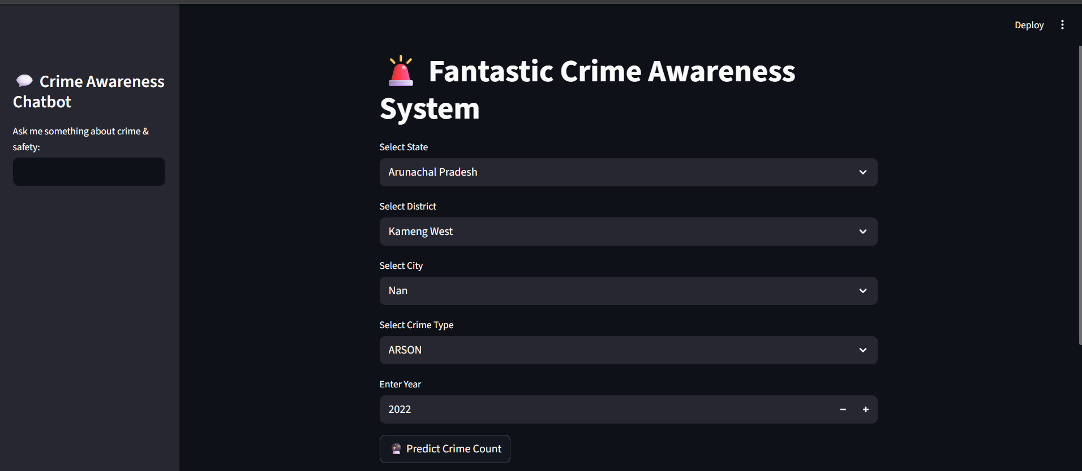

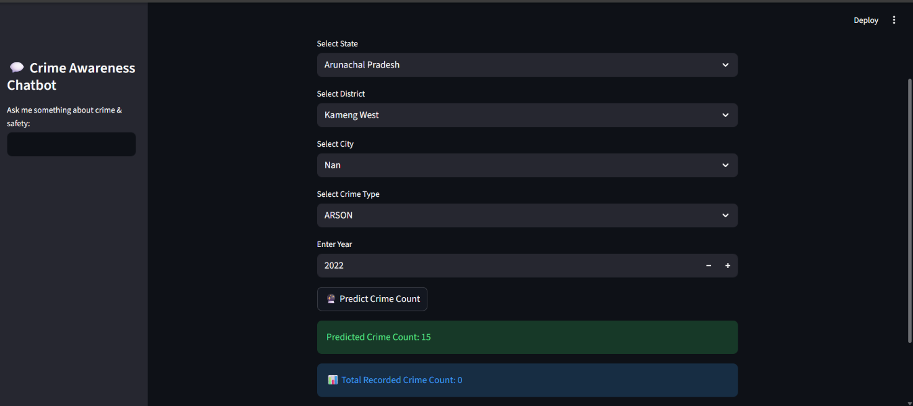

The Streamlit application provides a clean and interactive user interface. Screenshots should be included in the final report to visually demonstrate how the system works. Typical screens include the homepage with dropdown menus for state, district, city, year, and crime type. Another screenshot shows the output section with the predicted crime count and actual historical data. A separate panel displays literacy rate, population, police station count, and area of the selected region. The sidebar screenshot showcases the built-in safety chatbot with its responses.

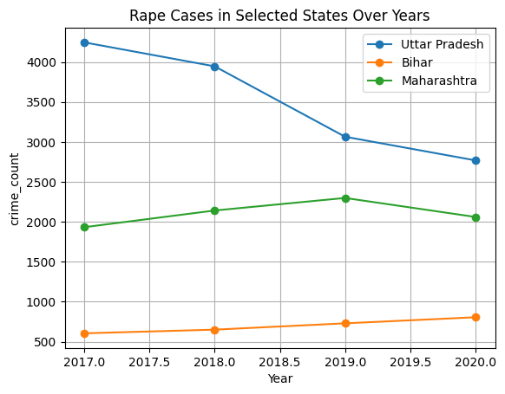

Figure 4.1 cases in Selected States Over Year
Figure 4.1 cases in Selected States Over Year

Rape Cases in Selected States Over Years
This line graph represents the trend of reported rape cases in three major Indian states — Uttar Pradesh, Bihar, and Maharashtra — from 2017 to 2020.
The x-axis shows the years, while the y-axis shows the number of crime _count cases recorded in each state.
✔ Uttar Pradesh
Has the highest number of cases throughout all years.
Shows a steady declining trend from around 4300 cases in 2017 to 2800 in 2020.
Indicates improved reporting or better policing, but also suggests high base crime levels.

✔ Maharashtra
Exhibits a moderate level of cases (1900–2300 range).
Shows a slight increase from 2017 to 2019, and a decrease afterward.
✔ Bihar
Records the lowest number of cases among the three states.
Shows a consistent upward trend from around 600 cases in 2017 to nearly 800 in 2020.

Interpretation:
This figure helps compare crime trends between states. It shows that:
Crime patterns vary significantly by region.
Uttar Pradesh experienced a declining trend,
Maharashtra saw a peak in 2019,
Bihar shows a continuous increase.
This type of visualization is useful for:
✔ understanding state-level trends
✔ highlighting hotspots
✔ supporting policy or administration decisions
✔ feature analysis in machine learning

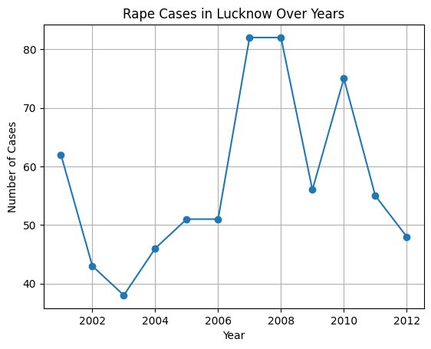
Figure 4.2 Rape Cases In Lucknow
This line graph shows fluctuating rape case numbers in Lucknow between 2001 and 2012, with major peaks around 2007–2008 and 2010.
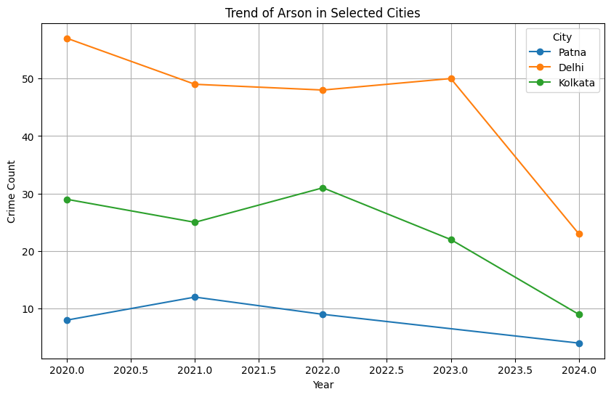
Figure 4.3 Trend of Arson in Selected Cases
This graph shows the trend of arson cases in three selected cities — Patna, Delhi, and Kolkata — from 2020 to 2024. Delhi consistently reports the highest number of arson cases, showing a decline from 2020 to 2022, a slight rise in 2023, and a sharp fall in 2024. Kolkata shows moderate fluctuations, while Patna has the lowest values and shows a gradual decline after 2021. The graph highlights how arson crime levels vary across different cities over time.

TESTING
Testing is an essential part of any software or machine-learning project. It ensures that the system works correctly, produces accurate results, and handles data smoothly. The Crime Awareness System underwent multiple testing stages, including unit testing, integration testing, system testing, and machine-learning model accuracy testing. Each of these levels checked different aspects of performance, usability, and reliability.

5.1 Unit Testing (Paragraph)
Unit testing focuses on checking individual components of the system to ensure they work correctly on their own. In this project, each small part—such as loading datasets, applyinglabel encoders, predicting values, and filtering user selections—was tested independently. For example, individual tests were performed to verify that each CSV file loads without errors, encoders convert text to numbers correctly, and user inputs are captured accurately by dropdown components in the Streamlit

  - Integration Testing (Paragraph)
Integration testing ensures that different modules of the system work together smoothly. After verifying individual units, the ML model, encoders, dataset loader, and frontend interface were connected and tested as a group. Integration testing checked whether encoded inputs from the frontend could successfully pass into the trained model and whether the model’s output correctly displayed in the Streamlit app. It also ensured proper interaction between modules, such as dropdown selection → encoding → prediction → state information display. This testing stage helped validate that the entire prediction pipeline worked without breaking at any point.
  - System Testing (Paragraph)

System testing examines the entire Crime Awareness System as a whole, simulating how a real user would interact with it. The complete workflow was tested—from selecting a state, district, and city to generating a crime prediction and viewing historical data.

  - Model Accuracy Testing (Paragraph)
Model accuracy testing focuses on evaluating the performance of the trained Random Forest model used for crime prediction. Various machine-learning evaluation metrics were used, including R2 Score, Mean Absolute Error (MAE), and Mean Squared Error (MSE). The R2 Score checked how well the model fits the data by measuring the variance explained
CONCLUSION
6.1 Summary
The Crime Awareness System Using Machine Learning successfully demonstrates how data-driven techniques can be used to understand and predict crime patterns in different regions. By using historical datasets and a trained Random Forest model, the system helps users gain insights into crime trends at the state, district, and city levels. The Streamlit-based web interface makes the system easy to use by allowing users to select crime parameters and instantly view predictions and actual historical data. The
6.2 Result
The system provides accurate crime count predictions based on the provided inputs by using a well-trained Random Forest Regression model. The predictions align closely with the historical data, proving the model’s reliability. The frontend interface displays the predicted crime count along with actual crime figures from the dataset, enabling easy comparison. Additionally, the system presents demographic and administrative details such as population, literacy rate, number of police stations, and area of the state.
6.3 Limitations
Despite its usefulness, the system has certain limitations. First, the accuracy of predictions depends entirely on the quality and completeness of the historical dataset. Missing or outdated data may reduce prediction reliability. Second, the model does not perform real-time crime monitoring; it only predicts based on past records. Third, label encoding may not capture the full relationships between cities or crime types. Another limitation is that the chatbot is basic and provides only limited predefined responses. Finally, the system requires manual dataset updates to improve accuracy over time.

6.4 Future Enhancements
There are several ways to further improve this project. The system can be enhanced by adding real-time crime data APIs to make predictions more dynamic and up to date. Advanced algorithms such as LSTM, XGBoost, or Neural Networks can be used to improve prediction accuracy. The chatbot can be upgraded into a fully AI-powered assistant capable of answering detailed safety questions. A map-based visualization feature could be added to show crime hotspots on an interactive map. Future versions may also include SMS/email alerts, crime category comparisons, and predictive heatmaps. With further improvements, the system can become a powerful tool for government agencies, police departments, and public safety organizations.

LIST OF FIGURES

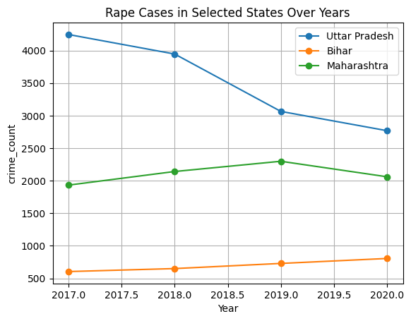
Figure 4.1 cases in Selected States Over Year

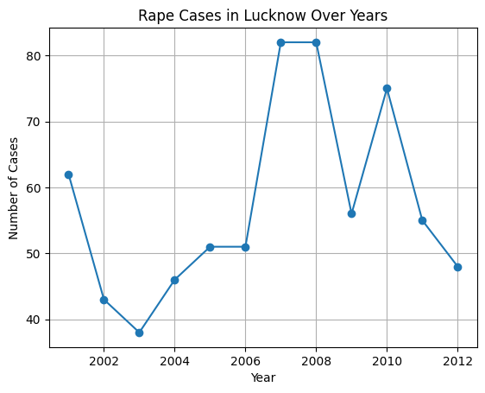
Figure 4.2 Rape Cases In Lucknow

- 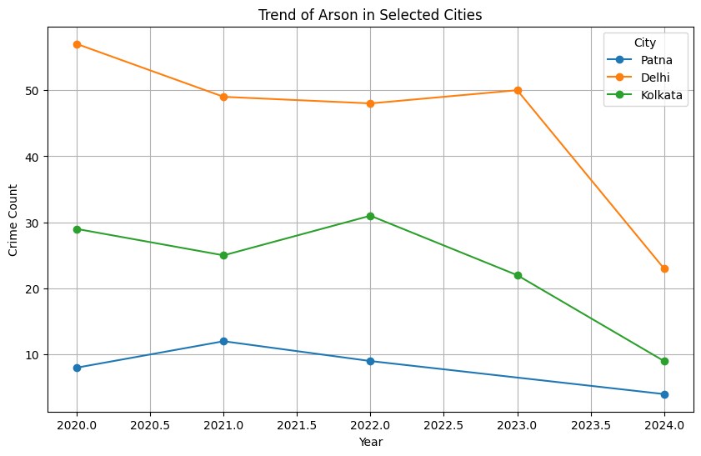

Figure 4.3 Trend of Arson in Selected Cases

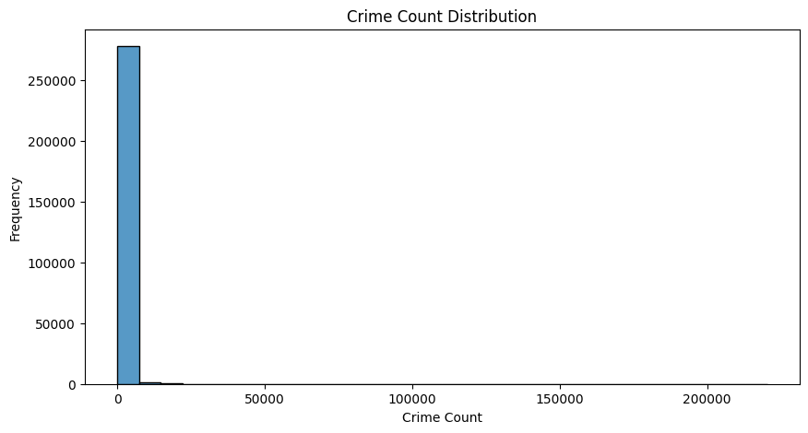
Figure 4.4 Crime Count Distribution

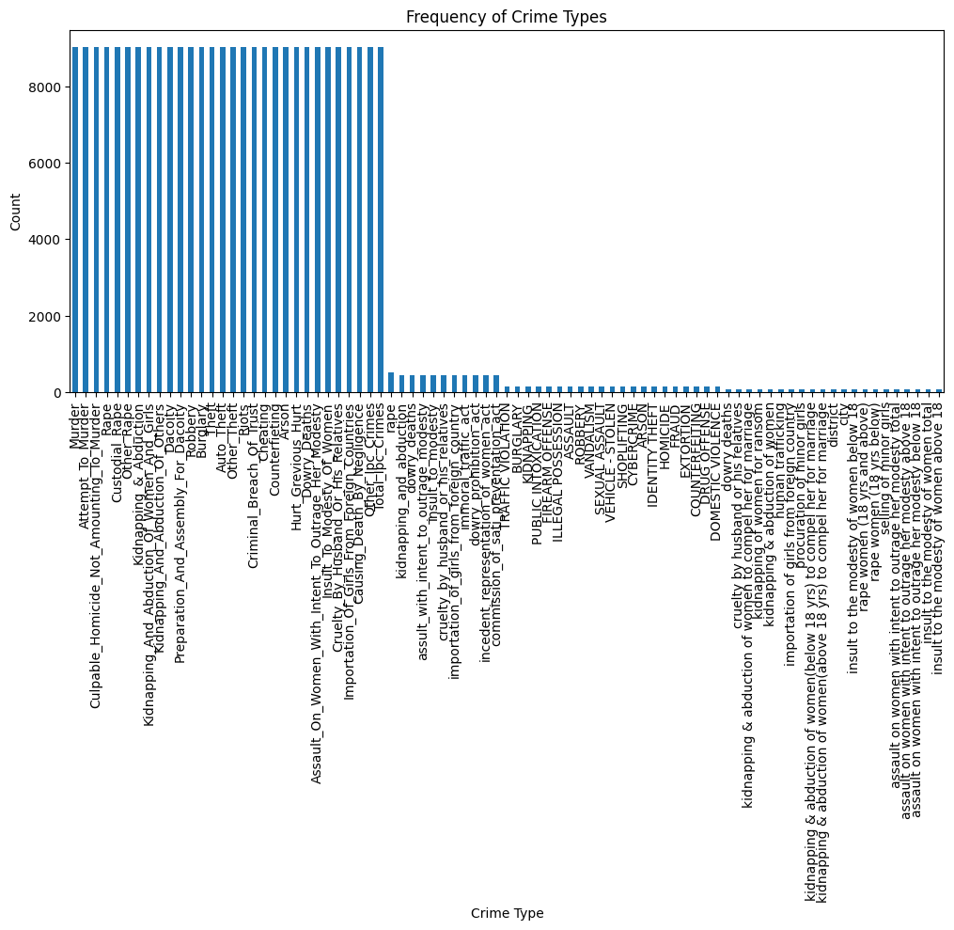
Figure 4.5 Frequency of Crime Types

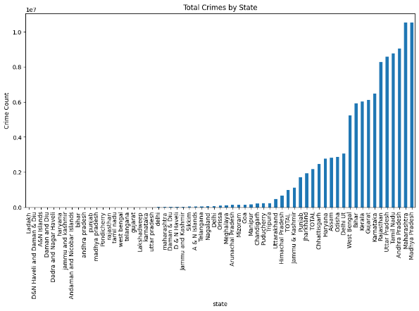
Figure 4.6 Total Crimes by States

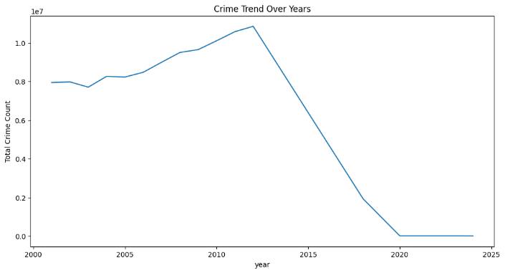
Figure 4.7 Crime Trend Over Year
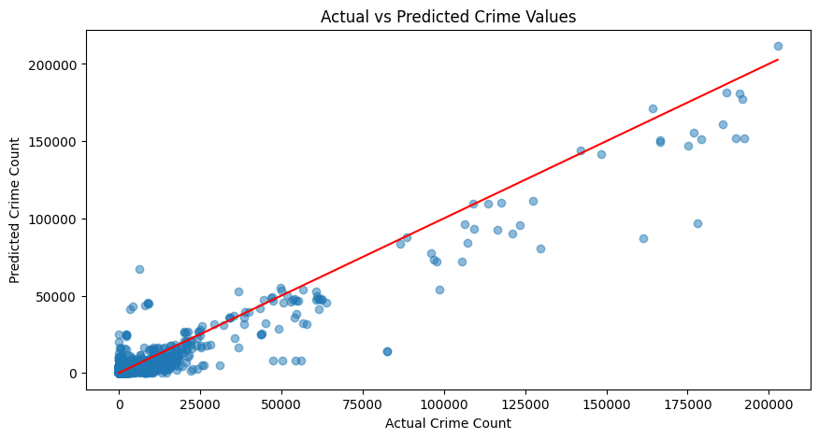
Figure 4.8 Actual vs Predicted Crime Values
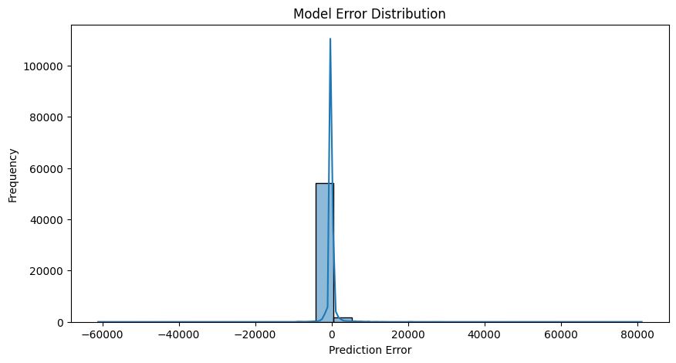
Figure 4.9 Model Error Distribution
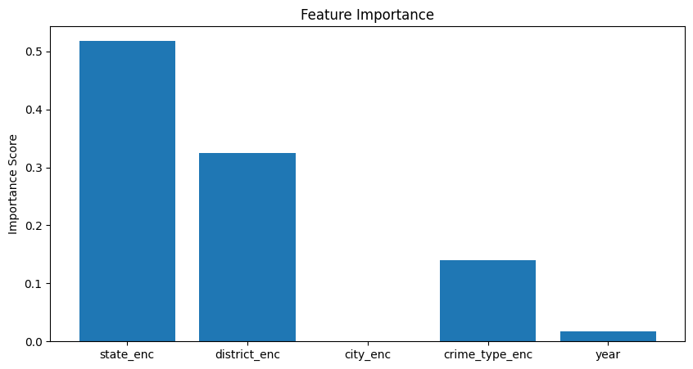
Figure 5.0 Feature Importance

REFERENCE

- Bishop, C. M. (2006). Pattern Recognition and Machine Learning. Springer.
- Han, J., Kamber, M., & Pei, J. (2011). Data Mining: Concepts and Techniques. Morgan Kaufmann.
- Scikit-learn Developers. “Scikit-learn: Machine Learning in Python.” scikit-learn.org.

- Pedregosa, F., et al. (2011). “Scikit-learn: Machine Learning in Python.” Journal of Machine Learning Research, 12, 2825–2830.
- Crime Data from Government Open Data Portal. data.gov.in.
- National Crime Records Bureau (NCRB). “Crime in India Report.” ncrb.gov.in.
- Aggarwal, C. (2015). Data Mining: The Textbook. Springer
- McKinney, W. (2010). “Data Structures for Statistical Computing in Python.” Proceedings of the 9th Python in Science Conference. (For Pandas)
- Hunter, J. D. (2007). “Matplotlib: A 2D Graphics Environment.” Computing in Science & Engineering.
- YouTube Tutorials and Articles on Crime Prediction & ML Algorithms (as supplementary learning sources).

